**#20198** - <https://redmine.vnc.biz/issues/20198>

1. **Description**:

* Allow the user-text input field in the conversation window to increase it size up to 4 lines before starting to scroll.
* The user wants to be able to see the whole message before sending.
* See attached images for reference:

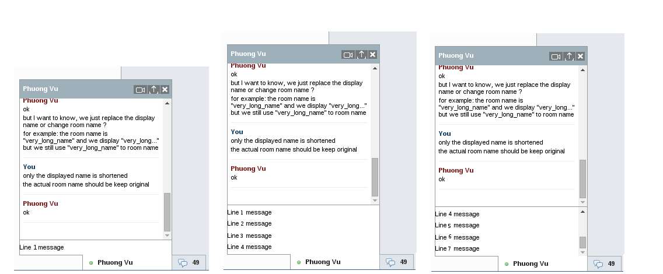

**Rainer**: I do not like that the test scrolls to the right if the message is too long

Therefore instead of scrolling to the right, the text will be arranged in a new line, if it is longer than the window width.

The input message field will increase up to 4 lines.

1. **Analytic**
   1. **Root cause**:
   2. **Solutions**:

- Change type element "input" to "textarea":

+ Can make more lines

+ Use the "Enter" / "Shift + Enter" key to get new line.

- Custom window chat when increase height input field and also decrease receive message field.

- Handle "Enter" key to send message and "Shift + Enter" key to get new line.

- Auto scroll receive message field when increase height input field.

- Edit function self.sendMessage:

+ Handle data to send message.

+ Clear data when sent message.

+ Return default height when sent message

- Replace JQuery "input.jm_send-messages" to "textarea.jm_send-messages".

1. **Implementation**
   1. **Code:**

- Change type element "input" to "textarea":

+ Can make more lines

+ Use the "Enter" / "Shift + Enter" key to get new line.

|  |
| --- |
| '<form action="#" method="post">' +  '<textarea class="jm_send-messages" name="body" autocomplete="off" placeholder="' + JappixCommon._e("Chat") + '" data-value="" data-chatstates="true" data-composing="off" data-chatstate="inactive" style="width: 260px; min-height: 16px; max-height: 80px; line-height: 1.5em; margin-left: auto; margin-right: auto; padding: 5px; height: 26px;"></textarea>' +  '<input type="hidden" name="xid" value="' + xid + '" />' +  ‘<input type="hidden" name="type" value="' + type + '" />' +  ‘</form>' + |

- Custom window chat when increase height input field and also decrease receive message field.

- Handle "Enter" key to send message and "Shift + Enter" key to get new line.

- Auto scroll receive message field when increase height input field.

|  |
| --- |
| self.chatEvents = function(type, xid, hash) {  …  // auto height when chat area  current_sel.find('textarea').on('keyup', function(){  if (event.which == 13) {  if (!event.shiftKey) {  form = current_sel.find('form');  return self.sendMessage(form);  };  };  this.style.height = "5px";  this.style.height = (this.scrollHeight)+"px";  height_chat_content = current_sel.find('.jm_chat-content').height();  height_actions = current_sel.find('.jm_actions').height() + 18;  height_send = current_sel.find('form').height() + 5;  result_height = height_chat_content - height_actions - height_send;  current_sel.find('.jm_received-messages').css({"max-height":"", "height": + result_height});  hash = current_sel.attr('data-hash');  self.messageScroll(hash);  return;  });  ...  } |

- Edit function self.sendMessage:

+ Handle data to send message.

+ Clear data when sent message.

+ Return default height when sent message

|  |
| --- |
| self.sendMessage = function(aForm) {  try {  var body = jQuery.trim(aForm.find('textarea').val());  var xid = aForm.find('[name=xid]').val();  var type = aForm.find('[name=type]').val();  var hash = hex_md5(xid);  if(body && xid) {  …  // Clear the input  aForm.find('textarea').val("");  //Set default height chat message window.  aForm.find('textarea').css({"height": "26px"});  // clear height of received messages window.  $('#received-'+ hash +'.jm_received-messages').css("height","");  ... |

- Replace JQuery "input.jm_send-messages" to "textarea.jm_send-messages".